Name: Date: Period:
Modeling sea floor spreading
Summary
In this activity students will use actual data from historic oceanographic cruises to examine sea floor spreading. They will also model sea floor spreading at a spreading center such as the Mid-Atlantic Ridge.

Learning Objectives
At the completion of this activity you should be able to:
• Plot data on a diagram.
• Draw conclusions from the data.
• Make predictions about future events related to this data.
Materials
• Student Handout
• Posterboard /cardstock
• Paper
• Scissors
Background
Using actual data from the Glomar Challenger cruises will allow you to see a real-world connection between classroom science and “real” science. Also, creating a model for sea floor spreading will allow you to see a hands-on example of this phenomenon.

Procedure
Part 1
- To create a working model of sea floor spreading, follow the model seen below (Figure 1). The base is best if made from poster board or card stock. The width and length of the base are not critical, as long as they are at least 12 cm wide and 30 cm long. Cut 3 slits, each slightly more than 8 cm wide. One slit needs to be in the center, and the other two at either end of the base, at least 4 cm in from the ends. Label the slits A and B at either end.
- Cut out the plate strips and place them back to back (marked sides together with number 1 at the top) and tape the end as indicated (at the end nearest number 7.)
- Shade alternating strips to represent the reversals of the earth’s magnetic field. Be sure that the shading on either side of the strip match the alternate side.
- Put the two strips up through the bottom slit and then off to the slits at either end of the base. (Figure 2.)
- Thread the two strips through the center slit of the base, keeping the taped edge at the bottom. Pull the “North American Plate” strip down through slit “A” and the “Eurasian Plate” strip through slit “B”.
- Push the strips up from below until you can see numbers 3, 4, and 5 on top of the base.

Templates for plate strips
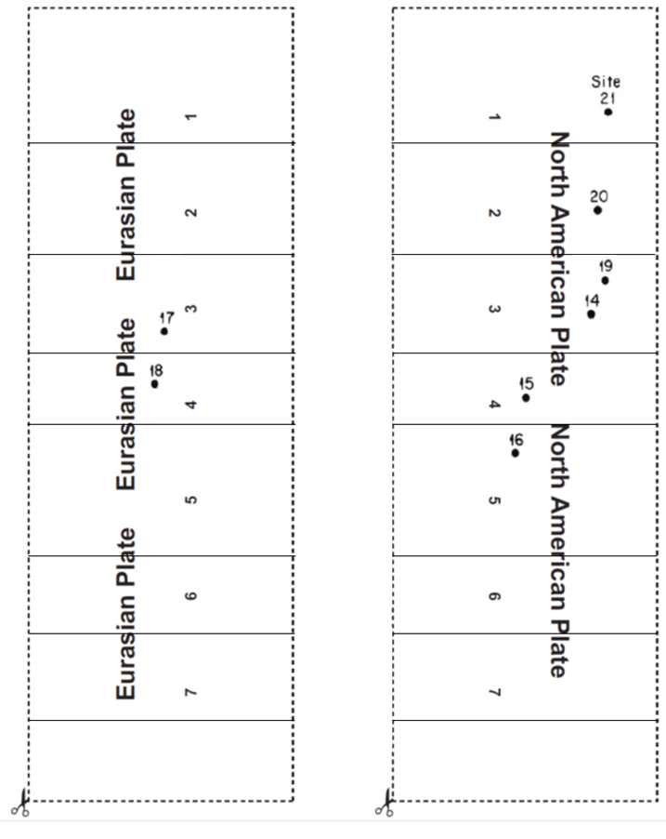

Analysis and Conclusion:

Use the data below and write the age of the sediments found at each site on the map below. (Write the age on the line by each site.) Then answer the questions on the next page.

(Please write in complete sentences!)

1. Where are the youngest sediments found, compared to the Mid-Atlantic Ridge?
2. Where are the oldest sediments found?
3. Does the data support the theory of sea floor spreading? How?

Use your spreading model to help you answer the following questions:

4. What are you modeling by pushing the strips up through the base?
5. What is being modeled at slits A and B as you pull the strips down through the base?
6. This model shows what happens at sea floor spreading centers, such as the mid-Atlantic Ridge. List at least 2 good points of this model.
7. What are at least 2 reasons why this model is not a good model?
8. Seafloor spreading is continuing today along mid-ocean ridges such as the Mid-Atlantic Ridge. Predict what effect this will have on the size of the ocean basin:

Calculate the rate of movement in cm per year for the six pairs of peaks. Use the
Formula rate = distance/time.

Convert kilometers to centimeters.

Example;

Using the data, calculate the speed of the movement of the plates, in centimeters per year. (Show your work!)

The North American Plate and the Eurasian Plate are moving apart at approximately_____________ cm per year.
Enrichment: Studying Seafloor Spreading on Land

Hopefully you are beginning to see how seafloor spreading changes the ocean floor. You should know that
magma rises at the mid-ocean ridge and flows away from the ridge forming new oceanic crust. In general, this activity is hidden beneath the ocean’s water. But there is a place where seafloor spreading can be seen on land.

1. What is the name of the landmass through which the mid-ocean ridge in the Atlantic Ocean passes? Where is it located?

2. How do the land structures of Iceland help confirm seafloor spreading?

3. Why do you think geologists might find Iceland a useful place to conduct research on seafloor spreading?

